Blood and Bone Marrow Morphology – Malignant Diseases
Mark Fleming

- A 16-year-old boy presents with pallor and bruising. Blood smear shows anemia, thrombocytopenia, and leukocytosis (100,000/mm³, 90% immature cells). Flow cytometry on blood shows cells are TdT+, CD10+, CD3+, CD7+, CD4+, and CD8+.
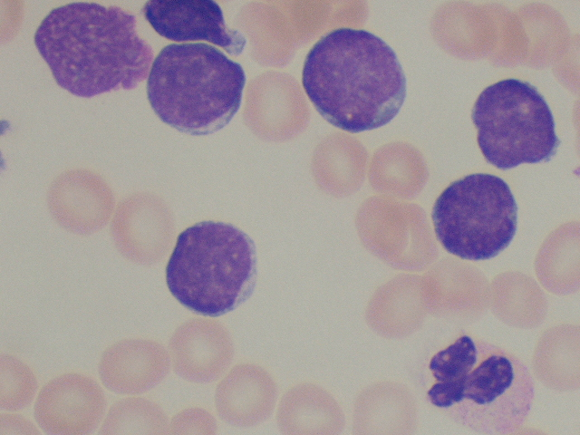
What is the most likely diagnosis for this patient?

- Acute myeloid leukemia (AML)
- B-cell acute lymphoblastic leukemia (ALL)
- T-cell ALL
- Hematogones
- Mononucleosis

Explanation
The cells are lymphoblasts by morphology and T cell by flow cytometry. Hematogones are rarely seen in peripheral blood in such large numbers. The atypical lymphs in infectious mononucleosis are T cells but are larger and have abundant cytoplasm, often with scant cytotoxic granules, and are mostly CD8 bright positive. Very high white count, male sex, and age of this patient, even in the absence of a mediastinal mass, should make one consider T-cell ALL.

- A 6-year-old boy with bone pain is referred to you. Blood smear shows pancytopenia and 5% circulating immature cells (pictured). Flow cytometry on marrow shows 80% of cells are TdT+, CD10+, CD19+, CD20–.

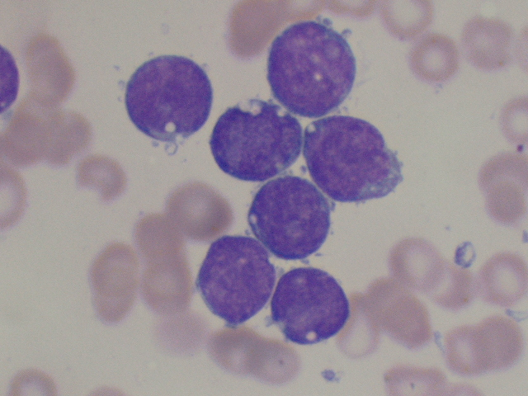
What is the most likely diagnosis for this boy?

- Acute myeloid leukemia (AML)
- B-cell acute lymphoblastic leukemia (ALL)
- T-cell ALL
- Hematogones
- Mononucleosis

Explanation
These cells are morphologically lymphoid and have an immature B phenotype by flow cytometry. Hematogones should show more of a spectrum of maturation and are unlikely to completely replace the normal marrow elements. Burkitt leukemia (BL) certainly is in the differential diagnosis, particularly given the vacuolization of the cells. The immunophenotype is supportive of BL other than the TdT positivity and lack of CD20 expression. Clonal surface immunoglobulin staining and an MYC translocation by cytogenetics/fluorescence in situ hybridization (FISH) would also be present in BL.

- A 7-year-old boy presents with recent onset of vomiting and lethargy. Blood smear shows increased neutrophils with a left shift and 8% abnormal cells. Bone marrow contains 60% of the same cells. Flow cytometry shows that the cells are TdT–, CD10+, CD19+, CD20+, sIg+.
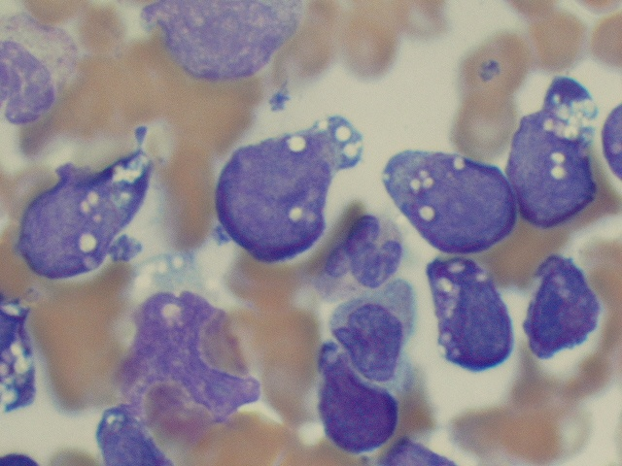
What is the most likely diagnosis?
- Burkitt leukemia/lymphoma
- B-cell acute lymphoblastic leukemia (ALL)
- T-cell ALL
- Hematogones
- Diffuse large B-cell lymphoma (DLBCL)

Explanation
Flow cytometry shows mature CD10+ B-cells, and the morphology is that of Burkitt lymphoma, which occasionally can have a leukemic phase. DLBCL certainly is a consideration, but a truly leukemic phase (rather than just marrow involvement) would be unusual. An MYC rearrangement by cytogenetics/fluorescence in situ hybridization (FISH) also would be diagnostically helpful.

- You are seeing a 13-year-old boy with fatigue, weight loss, night sweats, and splenomegaly. Peripheral blood shows anemia, thrombocytosis, and leukocytosis (300,000/mm³).
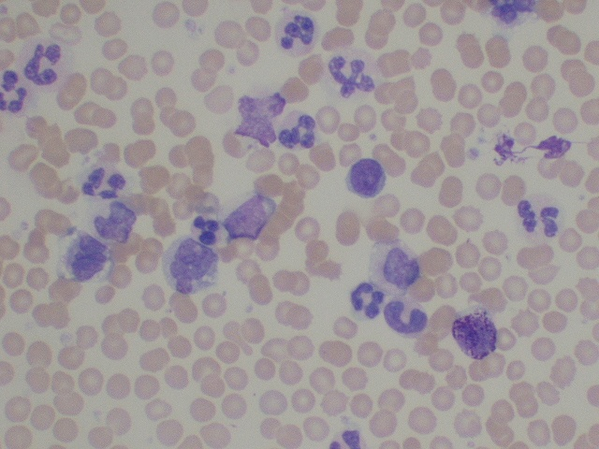
What is this patient’s most likely diagnosis?

- Leukemoid reaction
- Acute lymphoblastic leukemia (ALL)
- Chronic myeloid leukemia (CML)
- Juvenile myelomonocytic leukemia (JMML)
- Acute myeloid leukemia (AML)

Explanation
A neutrophilic leukocytosis and a left shift with a basophilia and thrombocytosis without increased blasts are typical of the chronic phase of CML. Cytogenetics/fluorescence in situ hybridization (FISH) showing t(9;22)(q34;q11.2) would be diagnostic. Leukemoid reaction is also in the differential, but basophilia and an absence of monocytosis would be unusual. JMML is a disease of much younger children (typically younger than 4 years and certainly younger than 8 years) and nearly always is associated with thrombocytopenia.

- You are seeing a 2-year-old girl with new onset of fever and bronchitis. She has maculopapular rash and hepatosplenomegaly. Blood smear shows leukocytosis (100,000/mm³), anemia, and thrombocytopenia. Ancillary tests include fetal hemoglobin of 80% and normal blood karyotype.
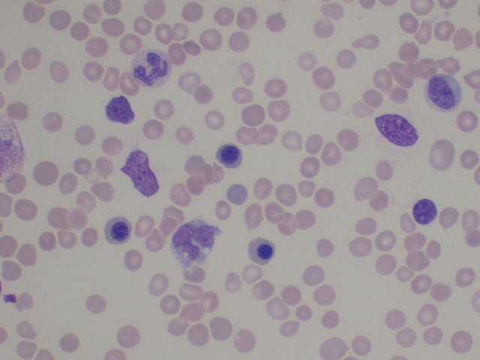
What is the most likely diagnosis?

- Leukemoid Reaction
- Acute lymphoblastic leukemia (ALL)
- Chronic myeloid leukemia (CML)
- Juvenile myelomonocytic leukemia (JMML)
- Acute myeloid leukemia (AML)

Explanation
Marked leukocytosis, including monocytosis without increased blasts or a basophilia, are typical of JMML, as are thrombocytopenia and anemia often accompanied by erythroblastosis. Elevation of fetal hemoglobin is characteristic of JMML. Cytogenetics typically are normal and a BCR/ABL1 fusion is not present. Somatic mutations in the RAS signaling pathway are common.

- A 1-year-old boy is referred for pallor and a rash. Blood smear shows pancytopenia and circulating abnormal cells.
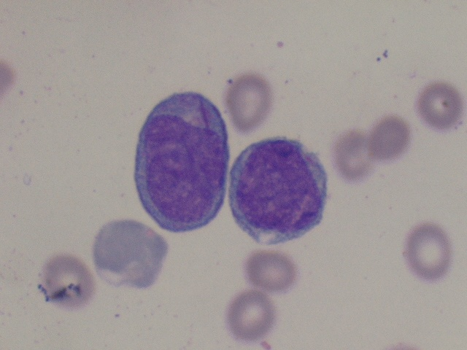
What is the most likely diagnosis for this child?

- Acute myeloid leukemia (AML)
- Chronic myeloid leukemia (CML)
- Juvenile myelomonocytic leukemia (JMML)
- Acute lymphoblastic leukemia (ALL)
- Large granular lymphocytic (LGL) leukemia

Explanation
The large blasts with ample cytoplasm and prominent nucleoli are suggestive of AML, but the Auer rod is diagnostic of AML.

- An 8-year-old boy presents with bruising. Blood smear shows anemia, thrombocytopenia, and leukocytosis (30,000/mm³, 50% blasts). Flow cytometry on marrow shows 50% blasts with TdT+, MPO+, CD13+, CD33+, and variable CD19+.
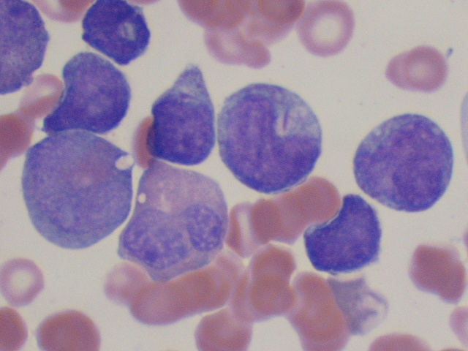
What is the most likely diagnosis?

- Acute myeloid leukemia (AML)
- Chronic myeloid leukemia (CML)
- Acute lymphoblastic leukemia (ALL)
- Myelodysplastic syndrome (MDS)
- Large granular lymphocytic (LGL) leukemia

Explanation
Morphology shows dysplastic myeloid maturation, blasts with “salmon pink granules,” and large Auer rods. Flow cytometry shows a myeloid phenotype with coexpression of CD19 and TdT. Although this is a “mixed” myeloid and B lymphoid phenotype (mixed phenotype acute leukemia [MPAL]), this constellation of findings is highly associated with t(8;21)(q22;q22) and RUNX1/RUNX1T1 fusion (ie, AML with a recurrent cytogenetic abnormality) and is defined as such as AML regardless of the phenotype or blast count.

- You are evaluating an 8-year-old girl with fever and palpable, nonpainful macular skin lesions. Blood smear shows anemia, thrombocytopenia, and leukocytosis (140,000/mm³, 60% blasts). Auer rods are not present. Flow cytometry shows 60% blasts that are CD34+, CD13+, CD33+, CD64+, CD11b+/–, MPO–/+.
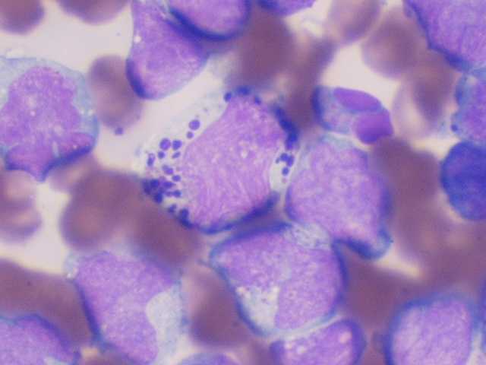
What is the most likely diagnosis?

- Chediak-Higashi
- Basophilic Leukemia
- Acute myeloid leukemia with abnormal eosinophils (AML-M4Eo)
- Acute promyelocytic leukemia (APML)
- Acute lymphoblastic leukemia (ALL)

Explanation
The blasts have a monocytic morphology and a myelomonocytic phenotype, so this is AML. The strange, darkly granulated cells are abnormal eosinophils (“Eo-Basos”), a morphology that correlates with a karyotype of inv(16) or t(16;16).

- A 13-yo girl presents with fever and swelling in one leg. Blood smear shows anemia and thrombocytopenia. Her WBC is 3,400/mm³ with marked left shift. Marrow has 82% immature myeloid cells, as shown. Flow cytometry on marrow shows MPO+, CD33+, CD13+ subset, HLA-DR–, CD34–.
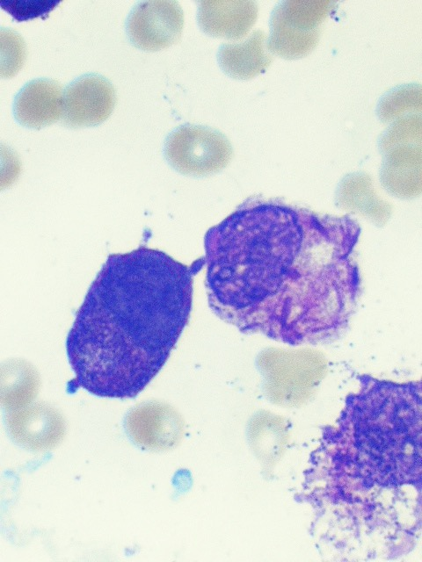
What is the most likely diagnosis?

- Toxic maturation arrest
- Acute promyelocytic leukemia (APML)
- Chronic myeloid leukemia (CML)
- Mast cell leukemia
- Technical artifact

Explanation
Atypical promyelocytes, which may have multiple Auer rods, rather than blasts characterize APML, which is associated with t(15;17) and a PML/RARA fusion. These “blast equivalents” are typically HLA-DR and CD34 negative

- You are evaluating a 19-year-old girl with a history of treatment for anaplastic large cell lymphoma (ALCL) 2 years ago. She presents now with persistent pancytopenia (WBC 800/mm³, no circulating blasts). Marrow has 80% abnormal cells that by flow cytometry are MPO–, CD33+, CD34–, CD13+, CD11b+, CD14+.
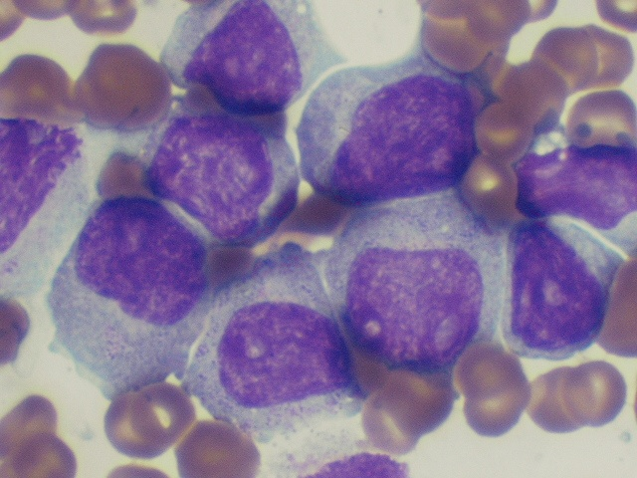
What is the most likely diagnosis for this patient?

- Relapsed ALCL
- Juvenile myelomonocytic leukemia (JMML)
- Acute lymphoblastic lymphoma (ALL)
- De novo acute myeloid leukemia (AML)
- Therapy-related AML

Explanation
The morphology and flow cytometry are those of monoblasts, which is characteristic of therapy-related AML, especially with rearrangements of the KMT2A (MLL) gene at chromosome 11q23.

- You are evaluating a 1-year-old boy referred to you with fever and weight loss. Blood shows anemia and neutropenia with 5% circulating blasts. Marrow has 95% abnormal cells that by flow cytometry are MPO–, CD33+, CD34–, HLA-DR–, CD41+, CD61+.
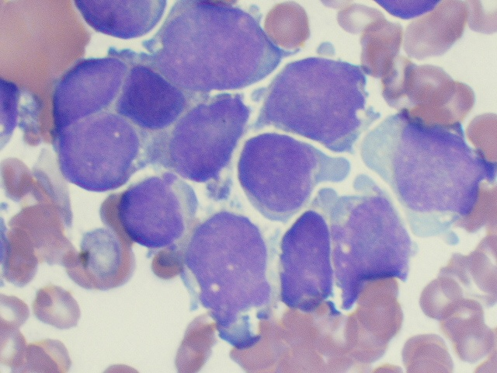
What is the most likely diagnosis?

- Acute myeloid leukemia (AML)
- Acute megakaryoblastic leukemia (AMKL)
- Transient abnormal myelopoiesis (TAM)
- Neuroblastoma
- Medulloblastoma

Explanation
The immunophenotype and marrow replacement indicate megakaryoblastic leukemia. Megakaryoblasts may be small, resembling lymphoblasts. Platelet-like cytoplasmic buds are common, but not specific.

- A 6-month-old girl presents with a large abdominal mass and elevated serum catecholamines. Bone marrow aspiration contains the cells pictured below. Flow cytometry shows the cells to be CD56+.
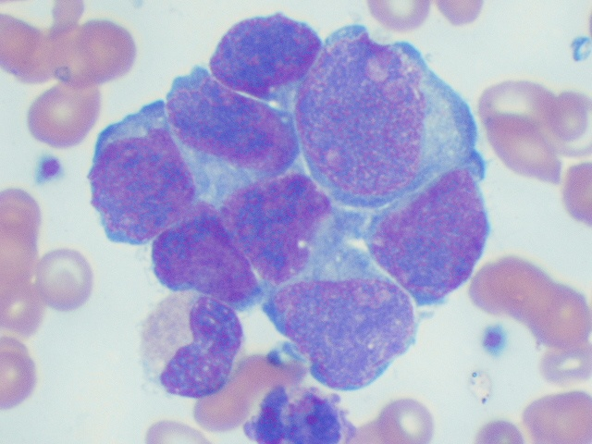
What is the most likely diagnosis for this infant?

- Acute myeloid leukemia (AML)/myeloid sarcoma
- Metastatic Wilms tumor
- Osteoblasts
- Natural killer (NK) cell leukemia/lymphoma
- Metastatic neuroblastoma

Explanation
Clumps of cells larger than most hematopoietic cells are most likely solid tumor. CD56 not only marks NK cells but also is a neural cell adhesion molecule. “Small round blue” cells, sometimes associated with pink fibrillary neuropil, in the clinical context of elevated catecholamines is characteristic of neuroblastoma. Clusters of osteoblasts, which are common in aspirates from children, can be mistaken for metastatic tumor.

