1.
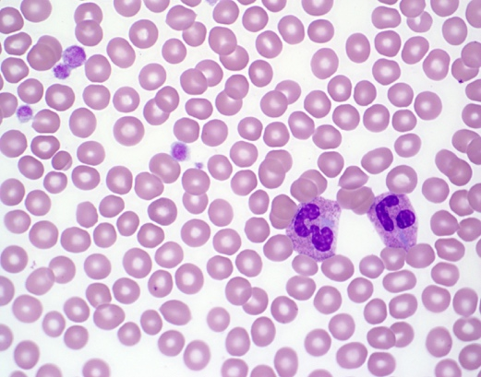

The patient is a 6-year-old boy referred to a hematologist for thrombocytopenia. He has no bleeding history or family history of bleeding. His only other past medical history is mild high-frequency hearing loss. What gene is responsible for these findings?

- NBEAL2
- GP-1Ba
- MYH9
- Deletions of long arm of chromosome 11
- GATA1

The peripheral blood smear shows macrothrombocytopenia with otherwise normal platelet granulation. The neutrophils have prominent Döhle-like cytoplasmic inclusions. The smear is consistent with May-Hegglin anomaly caused by mutations in MYH9. MYH9-related diseases include Epstein syndrome, Fechtner syndrome, and May–Hegglin anomaly.

Other genetic syndromes associated with giant platelets include Bernard-Soulier syndrome (GP-1Ba), grey platelet syndrome (NBEAL2), some patients with von Willebrand factor type 2b, and Paris-Trousseau thrombocytopenia (deletion of 11q23-terminus).

2.*
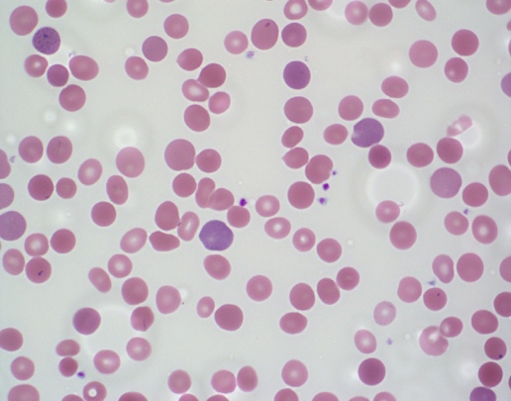

A 4-year-old boy is pale with intermittent jaundice and splenomegaly.

Laboratory results are as follows: RBC 4.85 M/mcL (N); Hgb 8.6 g/dL (L); Hct 25.8% (L); MCV 81.6 (N); MCHC 38% (H); RDW 20% (H); Retic 7% (H).

What are the two best tests to distinguish autoimmune hemolytic anemia from hereditary spherocytosis?

- Free erythrocyte protoporphyrin and IgG levels
- Hemoglobin electrophoresis and direct antiglobulin test (DAT)
- Lactate dehydrogenase (LDH) and modified Russell viper venom test
- Red cell distribution width (RDW) and mean corpuscular hemoglobin concentration (MCHC)
- DAT and osmotic fragility testing

The findings on the peripheral blood smear include small, dense, round microspherocytes; polychromasia; and red cells with central pallor, which are often smaller than normal. In this case, the direct antiglobulin test (DAT) was negative, and the patient was diagnosed with hereditary spherocytosis. A high mean corpuscular hemoglobin concentration (MCHC) (≥ 36 g/dL) is consistent with the presence of spherocytes.

Free erythrocyte protoporphyrin testing is useful is the evaluation of porphyrias. Hemoglobin electrophoresis is useful in the evaluation of hemoglobinopathies. The modified Russell viper venom test is useful in the evaluation of lupus anticoagulant.

Hereditary spherocytosis is caused by mutations in membrane skeletal proteins ankyrin, alpha-spectrin, beta-spectrin, band 3, or protein 4.2. Hereditary elliptocytosis is typically caused by heterozygous mutations in alpha-spectrin, beta-spectrin, or protein 4.1. Hereditary pyropoikilocytosis is typically caused by homozygous mutations in alpha-spectrin, beta-spectrin, or protein 4.1.

3.
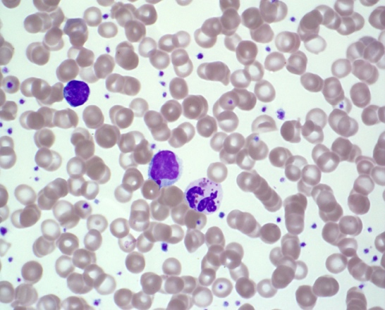

The patient is a 2-month-old boy who presented with a skin abscess and is febrile. On exam, he is noted to have silvery hair and hypopigmented skin. A CBC shows a leukocyte count of 3.4 K/mcL with 10% neutrophils. What does the abnormality on the peripheral smear suggest?

A. Abnormal lysosomal biogenesis
- Abnormal ribosome function
- Abnormal phagocytosis of opsonized particles
- Abnormal mitochondrial activity
- Impaired DNA repair activity

The peripheral blood smear shows abnormally large azurophilic or grey granules in the neutrophils and lymphocytes. These abnormal coalesced lysosomes can be found in all leukocytes.

Chediak-Higashi syndrome is due to abnormal lysosomal biogenesis. Patients in the stable phase have increased susceptibility to infection and oculocutaneous albinism. An accelerated phase with hemophagocytic lymphohistiocytosis is typically fatal.

Of the other choices, the following diseases are examples that have defects in the cellular system named:
- Diamond-Blackfan anemia characterized abnormal ribosomal function
- leukocyte adhesion deficiency characterized by abnormal phagocytosis
- Pearson syndrome characterized by abnormal mitochondrial activity
- ataxia-telangiectasia characterized by abnormal DNA repair.

4.*
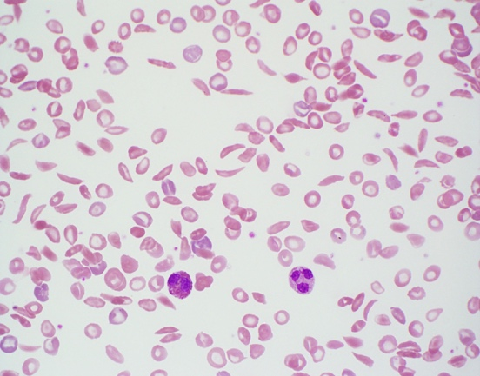

Which of the following tests can not be used to diagnose the disease show on this peripheral smear?

- Chorionic villus sampling at 8 to 10 weeks gestation
- Hemoglobin electrophoresis
- High performance liquid chromatography (HPLC)
- Osmotic fragility testing
- Solubility test

The peripheral blood smear shows a severe sickling crisis seen in patients with S/S or S/β⁰ genotypes. Substitution of the normal hydrophilic glutamic acid residue for the hydrophobic valine residue leads to pathologic polymerization when deoxygenated. Patients with sickle cell trait do not typically show any sickling on a peripheral blood smear but are solubility-test positive. Osmotic fragility is not increased by sickled cells and can be decreased in patients with sickle cell disease after splenectomy.

5.
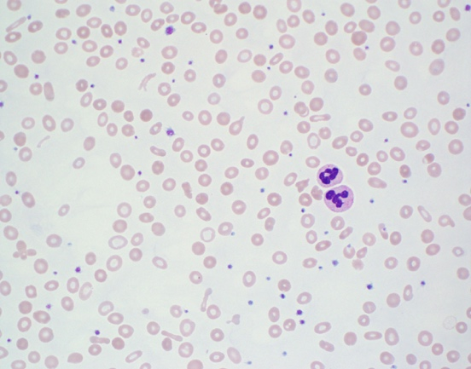

A 3-month-old girl presents with persistent microcytic anemia even with iron supplementation. Which of the following genetic alterations is consistent with the peripheral smear findings?

- Mutations in RPS19 gene
- Mutations in Codanin-1 (CDAN-1)
- Homozygous deletions of both Matripase-2 genes (TMPRSS6)
- Transcobalamin II deficiency (TCN2 mutations)
- Dihydrofolate reductase deficiency

The peripheral smear shows hypochromic microcytic anemia with anisopoikilocytosis. Elliptical (pencil) cells are present. There is mild thrombocytosis. This case is consistent with iron-refractory iron deficiency anemia. Matripase-2 normally reduces hepcidin protein expression by suppressing hemojuvelin. Loss of Matripase-2 leads to increased hepcidin, which limits dietary iron absorption and causes iron sequestration. All of the other mutations are associated with macrocytosis. RPS19 mutations cause Diamond-Blackfan anemia. Codanin-1 mutations cause congenital dyserythropoietic anemia (type 1). Transcobalamin II deficiency and dihydrofolate reductase deficiency both cause megaloblastic anemia.

6.*
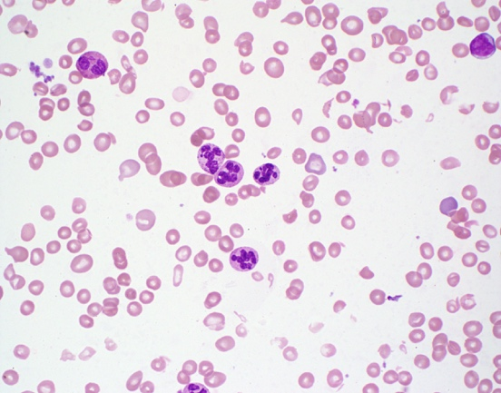

A 3-year-old boy presents with the finding shown in the smear. Which of the following nutritional deficiencies, if present, wound explain the smear findings?

- Cobalamin
- Cholecalciferol
- Thiamine
- Vitamin K
- Alpha-tocopherol

The peripheral blood smear shows hypersegmented neutrophils and mild macrocytosis with occasional ovalocytes. These finding are consistent with megaloblastic anemia caused by folate or cobalamin deficiency.

7.*
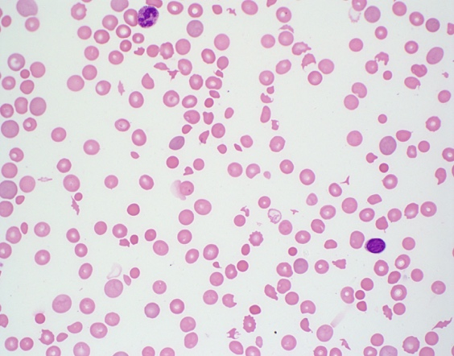

The patient is a 16-year-old boy with sudden onset of headache, fatigue, dyspnea, and petechiae. CBC reveals WBC of 5.6 K/mcL, HCT of 25 %, PLT of 17 K/mcL, and a reticulocyte count of 250 K/mcL

Which of the following disorders would not show similar findings on peripheral blood smears?
- Shiga toxin mediated hemolytic uremic syndrome
- Disseminated intravascular coagulation
- Complement mediated thrombotic microangiopathy
- Systemic infection
- Glucose 6-phosphate dehydrogenase deficiency

The peripheral blood smear shows polychromasia, thrombocytopenia, numerous schistocytes, spherocytes, and occasional helmet cells. This smear is consistent with microangiopathic hemolytic anemia (MAHA). MAHA is associated with several causes of thrombotic microangiopathy syndromes such as thrombotic thrombocytopenic purpura (TTP), hemolytic uremic syndrome (HUS), and atypical hemolytic uremic syndrome (aHUS). Other causes of MAHA include disseminated intravascular coagulation (DIC), infection, malignancy, preeclampsia, HELLP, and systemic rheumatic diseases.

8.

In January, a 16-year-old girl travels on a mission trip with her family to Nigeria. Upon her return, she reports episodic fevers. The laboratory technician calls you over to show you her findings. What are the inclusions shown in the smear most likely to be?

- Kayser-Fleischer rings
- Heinz bodies
- Cabot rings
- Babesia microti
- Malaria organisms

These inclusions are Plasmodium species. To speciate, look for morphologically characteristic extracellular schizonts and gametocytes. Cabot rings are rarely seen remnant microtubules of the mitotic spindle, which can be seen with megaloblastic anemia, congenital dyserythropoietic anemia, or myelodysplastic syndromes. Babesia organisms are ring-shaped intraerythrocytic organisms transmitted by the Ixodes scapularis tick found in the midwest and southeast United States.

9.
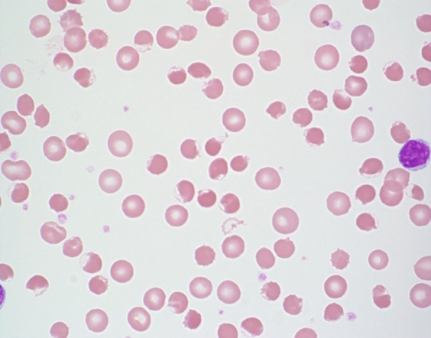

A 14 month old African American male presents with sudden onset of pallor, irritability, and dark colored urine. A CBC is notable for a hemoglobin level of 6.0 g/dL.

The findings on the peripheral smear are consistent with:
- Hereditary Spherocytosis
- Neuroacanthocytosis
- Glucose 6-phosphate dehydrogenase deficiency*
- Autoimmune hemolytic anemia
- Thermal injury

The findings on the peripheral smear are consistent with G6PDH deficiency. There are numerous blister cells on the smear (aka eccentrocytes).

Blister cells are formed by disruption of the cell membrane during removal of precipitated oxidized hemoglobin (Heinz bodies) followed by reattachment of the two ends of the membrane with vacuole formation.

Bite cells are also seen in G6PDH deficiency through removal of oxidized precipitated hemoglobin without vacuole formation.

10.
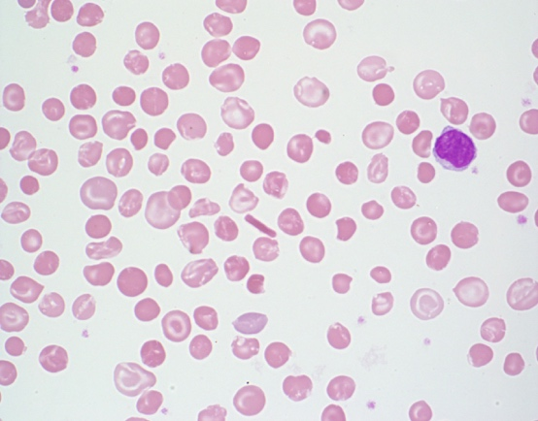

16 year old male from West Africa is referred to a local hematologist because of anemia and splenomegaly.

A CBC shows a hemoglobin of 10.2 g/dL; MCV of 75 fl, reticulocyte count of 152 k/uL; and MCHC of 39%

The patients smear is consistent with what genotype?

- Hemoglobin S trait
- Hemoglobin S/C disease
- Hemoglobin C trait
- Hemoglobin C disease*
- Hemoglobin E

The peripheral smear is consistent with Hemoglobin C disease. There are target cells, microcytosis, and reticulocytosis. There is a hemoglobin C crystal present in the center of the field.

Hemoglobin C is due to mutation of the hemoglobin beta chain which is less soluble than the normal beta chain and leads to crystallization. The crystals lead to red cell rigidity and decreased survival time. Hgb C, by itself, does not polymerize or cause sickling.

Both heterozygous and homozygous Hemoglobin C variants can lead to dehydration of the red cells and consequent increase of the MCHC. Hemoglobin C trait usually does not cause anemia.

11.
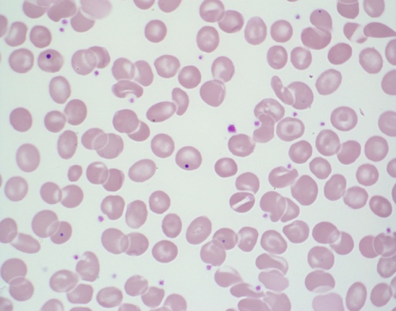

The patient is a 12 year old boy who is status-post splenectomy. As you review a peripheral smear for a patient with anemia, you notice intracellular red cell inclusions

What kind of inclusion is depicted on the slide? What material is the inclusion made from?

- Pappenheimer body: Iron-protein complexes in lysosomes
- Pappenheimer body: DNA (Nuclear remnant)
- Howell-Jolly body: DNA (Nuclear remnant)*
- Howell-Jolly body : Aggregated ribosomes with incomplete RNA degradation
- Basophilic stippling: Iron-protein complexes in lysosomes

H-J bodies consist of retained nuclear material and are visualized with Wright-Giemsa staining

They are small purple or purple-blue staining round objects of variable size. Usually one per cell, but can sometimes see two or more per cell.

Clinical conditions associated with H-J bodies:
Postsplenectomy
Functional asplenia (eg sickle cell disease)
Severe hemolytic anemia
Megaloblastic anemia
Congenital dyserythropoietic anemia
Occasionally in newborns especially in those born prematurely

12.
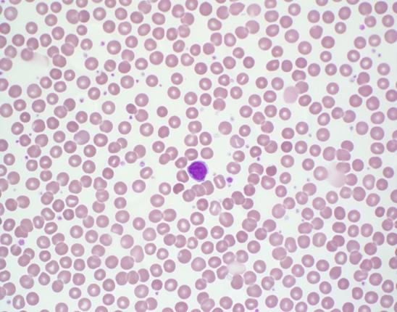

A two year old girl is referred to her local hematologist for ‘anemia’. The Hgb is 10.7 g/dL. Which is the most likely diagnosis based on the smear:

A. Hereditary spherocytosis
B. Hereditary elliptocytosis
C. Anemia of inflammation
D. Normal child*
E. Hereditary stomatocytosis

The peripheral blood smear is normal and the patient Hgb level is normal for age.

Various red cell morphologic findings (spherocytosis, stomatocytosis, schistocytes, etc.) at levels of 5% or less are commonly seen on normal peripheral blood smears.

13.
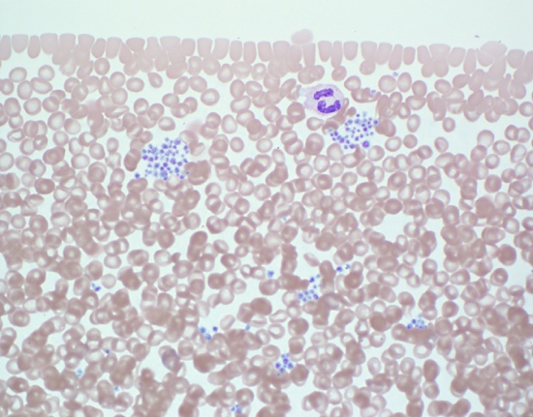

A 12 year old girl presents with thrombocytopenia (92 k/uL). She has no bleeding history or family history of bleeding. The physician suspects pseudo-thrombocytopenia. What kind of anticoagulant can cause in vitro platelet clumping, and what kind can be used to correct the clumping to get an accurate platelet count?

- Heparin/EDTA
- EDTA/Citrate
- Citrate/EDTA
- Heparin/Oxalate
- Oxalate/Citrate

The peripheral blood smear shows significant platelet clumping and is otherwise normal

Platelet clumping occurs occasionally with EDTA anticoagulation and will cause hemocytometer to undercount the number of platelets present.

EDTA can also cause platelets to adhere to leukocyte (platelet satellitosis)

Drawing a second sample with heparin as well as citrate anticoagulant should prevent clumping and permit a more accurate platelet count.

14.*
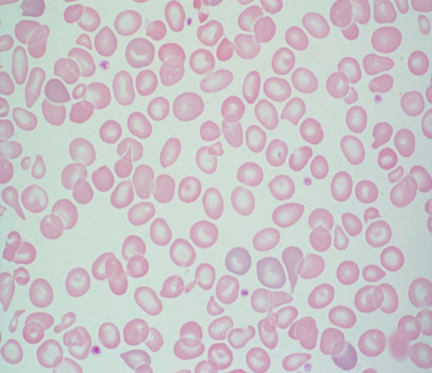

A 1 year old boy is followed by a hematologist and a CBC shows Hgb of 8.5 g/dL, MCV of 68.3 fL, MCHC 29 %, RDW 15.1 %, and reticulocyte count of 75 k/uL.

HPLC done at birth showed Hb Barts and patient was diagnosed with alpha thalassemia intermedia. If brilliant cresyl blue staining is done on these red cells, what red cell inclusion will likely be present?

A. Howell-Jolly bodies
B. Papenheimer bodies
C. Hemoglobin H inclusions*
D. Coarse basophilic stippling
E. Protoporphyrin rings

The findings on the peripheral smear include hypochromic microcytic anemia with anisopoikilocytosis, target cells, and basophillic stippling.

Hemoglobin H inclusions are precipitates of excess β tetramer chains

Not visible with Wright-Giemsa staining; must use supravital dyes such as brilliant cresyl blue

Inclusions appear as numerous small bluish granules distributed evenly throughout the cell

Clinical conditions associated with HGB H inclusions:
- Alpha thalassemia with deletion of 3 of the 4 genes.

15.
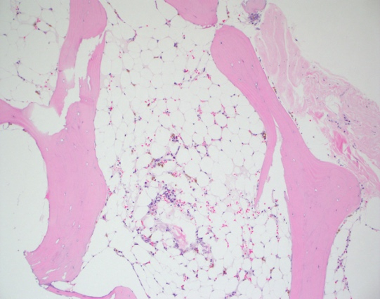

A 17-year-old male presents with pancytopenia. The bone marrow biopsy is pictured. Cytogenetics show 46,XY, and flow cytometry does not identify a dysplastic cell population. Which of the following additional testing should not be obtained?
- Send for telomere length evaluation.
- Perform diepoxybutane testing on the bone marrow.
- Evaluate for paroxysmal nocturnal hemoglobinuria (PNH) clones by flow cytometry
- Evaluate cell morphology by electron microscopy
- Perform hepatitis A, B, and C serological testing

The bone marrow biopsy is severely hypocellular (5%). With no evidence of cytogenetic abnormality or dysplasia, the biopsy is consistent with aplastic anemia. Workup of aplastic anemia includes evaluation for Fanconi (diepoxybutane [DEB] breakage studies), dyskeratosis congenita (telomere length studies), paroxysmal nocturnal hemoglobinuria (PNH) clones, and Hepatitis A/B/C serologies. Electron microscopy is not useful in the evaluation for aplastic anemia.

16.
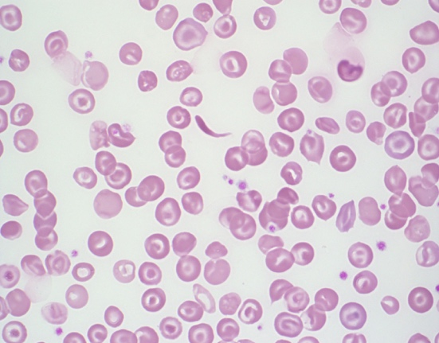

A five year old girl who is recently relocated from the Ivory Coast of West Africa is evaluated for anemia.

After the hematologist review the peripheral blood smear, she makes a provisional diagnosis of _______ and orders what further testing?

- Hemoglobin SS; osmotic fragility testing
- Hemoglobin CC: Hemoglobin electrophoresis
- Hemoglobin E: osmotic fragility testing
- Hemoglobin SC: Hemoglobin electrophoresis*
- Hemoglobin H disease: Supravital staining

The peripheral smear shows normocytic normochromic anemia with many target cells and rare sickled cells. The smear is consistent with Hemoglobin SC and confirmation would be made with hemoglobin electrophoresis.

The other choices would present with peripheral smears with more (Hgb SS) or no (Hgb CC, Hgb H, Hgb E) sickle cells.

17.
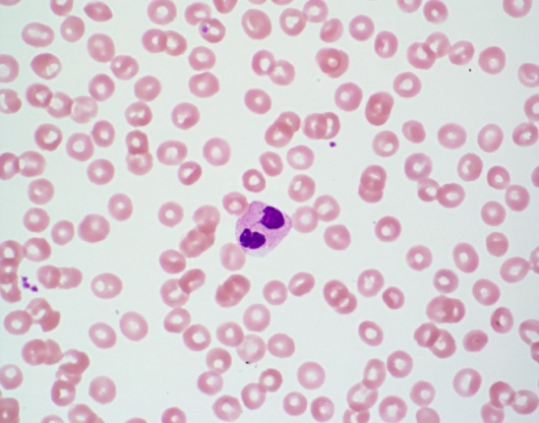

You review a peripheral smear from a healthy 10 year old boy and find many cells with the morphology of the leukocyte shown. This morphology results from:

- Heterozygous mutations in the Lamin B receptor gene*
- Homozygous mutations in the Lamin B receptor gene
- Homozygous mutations in the ELANE gene
- Heterozygous mutations in the SBDS gene
- Homozygous mutations in the LYST (CHS1) gene

The hyposegmented bilobed neutrophils seen on the peripheral smear in a well child is consistent with Pelger-Huët anomaly. This is caused by mutations in the Lamin B receptor. Heterozygotes have bilobed neutrophils while homozygotes have neutrophils with round unilobed nuclei.

Mutations in the ELANE gene are associated with severe congenital neutropenia

SBDS mutations result in Schwachman Diamond syndrome

LYST mutations result in Chediak Higashi syndrome

18.
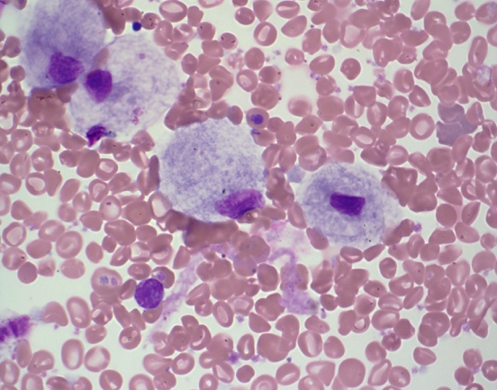

A 10 year old boy presents with mild anemia, thrombocytopenia. He has bone abnormalities and hepatosplenomegaly on radiographic imaging. Abnormal cells are present on the shown bone marrow aspirate. The molecular defect in this disease results in a deficiency of which enzyme:

- β-Glucocerebrosidase*
- α-L-iduronidase
- Lysosomal acid lipase
- Arylsulfatase A
- Acid sphingomyelinase

The cells on the bone marrow aspirate direct smear are Gaucher cells. Gaucher cells are reticuloendothelial cells of the monocytic lineage with lysosomes stuffed with glycosphingolipids.

The cytoplasm of the cells have the characteristic ‘wrinkled tissue paper’ appearance. This appearance is due to the enlarged and misshapen lysosomes.

α-L-iduronidase is deficient in mucopolysaccaridosis type I

Lysosomal acid lipase is deficient in Wolman disease and cholesteryl ester storage disease

Arylsulfatase A is deficient in Metachromatic leukodystrophy

Acid sphingomyelinase is deficient in Niemann-Pick Disease

19.
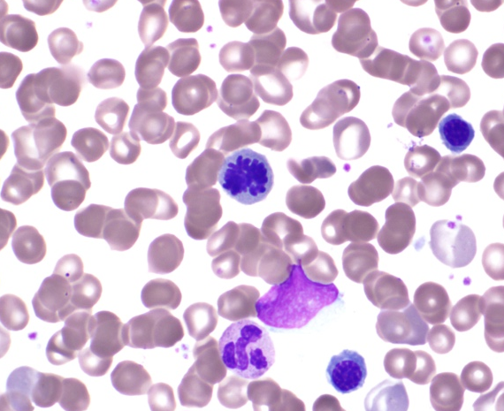

As you review a bone marrow aspirate, you occasionally identify cells with an unusual nuclear configuration. What cellular process is happening?

  - Apoptosis
  - Autophagy
  - Mitosis*
  - Karyorrhexis
  - Meiosis

The cell in question is a mitotic figure and is seen in cells undergoing mitosis

In mitosis, the chromosomes condense and are individually visible.

It is normal to see occasional mitotic figures in healthy marrows. Mitotic figures are greatly increased in neoplastic conditions.

20.

A bone marrow aspirate from an 8 month old infant who is acutely ill with a ferritin level of 12,000 shows which of the following abnormalities:

- Myelodysplastic syndrome
- Leishmaniasis
- Hemophagocytosis*
- Acute monocytic leukemia
- Gaucher disease

The bone marrow shows hemophagocytosis, and the patient should be worked up for Hemophagocytic Lymphohistiocytosis.

The macrophage in the left panel has engulfed mature red blood cells, platelets, and cellular debris.

The macrophage in the right panel has engulfed a neutrophil and an immature red cell.

21.
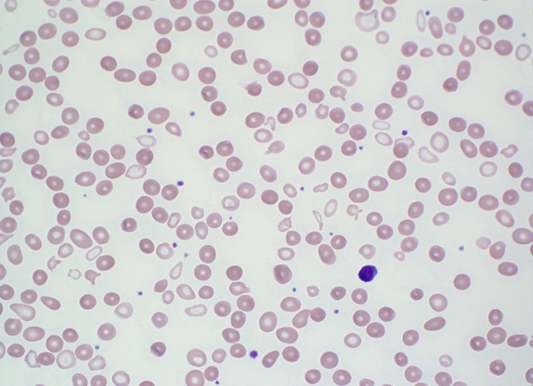

A 10 year old boy is evaluated for progressive anemia and is noted to have Hgb of 7.5 g/dL, low MCV of 69 fL, reticulocyte of 0.8%, high RDW of 19.1%, and elevated ferritin of 275 ng/mL.

Occasional Pappenheimer bodies are noted.

The lab results and peripheral smear are consistent with:

- Lead poisoning
- Homozygous hemoglobin E
- Severe copper deficiency
- Cobalamin deficiency
- Sideroblastic anemia*

Review of the peripheral smear reveals a dimorphic red cell population. One is pale and microcytic with poikilocytosis. The other is normochromic. Pappenheimer bodies (P) and occasional basophilic stippling are noted. Systemic iron overload occurs due to chronic ineffective erythropoiesis. Prussian blue staining of the bone marrow aspirate will reveal ringed sideroblasts (R) which are required for diagnosis. Genetic analysis of the current case revealed mutations in the δ-aminolevulinic acid synthase gene (ALAS2), consistent with X-linked sideroblastic anemia.
R
P

22.
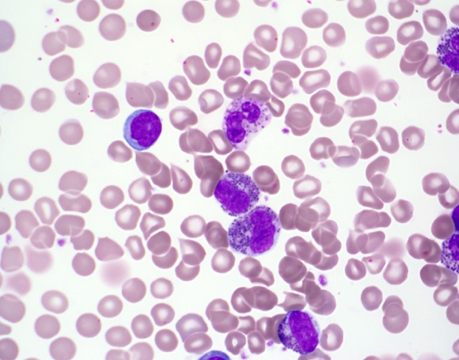

A 3 month old infant has a CBC performed and is referred to a pediatric hematologist due to the leukocyte abnormalities noted on the peripheral smear. What class of lysosomal storage disease does the smear suggest?

A. Sphingolipidoses (e.g., Gaucher, Nieman-Pick)
B. Mucopolysaccharidoses (e.g., Hurler, Hunter syndrome)*
C. Acid Lipase Deficiency (e.g, Wolman)
D. Neuronal Ceroid Lipofuscinoses
E. Metachromatic Leukodystrophy

The prominent azurophilic granulation seen in the leukocytes are an example of the Alder-Reilly anomaly.

This finding is seen in patients with mucopolysaccharidoses where there is lysosomal build up of mucopolysaccharide due to impaired catabolism.

Type 1: Hurler
Type 2: Hunter
Type 3: Sanfilippo Syndrome
Type 4: Morquio Syndrome
Type 6: Maroteaux-Lamy Syndrome
Type 7: Sly Syndrome

23.
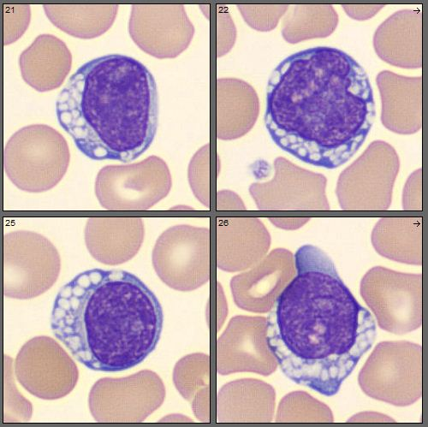

The morphologic findings in these peripheral blood cells are found in what disease category:

- Lysosomal storage diseases*
- Primary immunodeficiency syndromes
- Bone marrow failure syndromes
- Collagen vascular disorders
- Severe systemic infections

The cells shown are lymphocytes with cytoplasmic vacuoles which should make you think of lysosomal storage disorders.
Specific disorders reported to have vacuolated lymphocytes include:
- Mucopolysaccharidosis
- Galactosialidosis
- Mucolipidosis
- Juvenile neuronal ceroid lipofuscinosis
- GM₁ gangliosidoses

24.
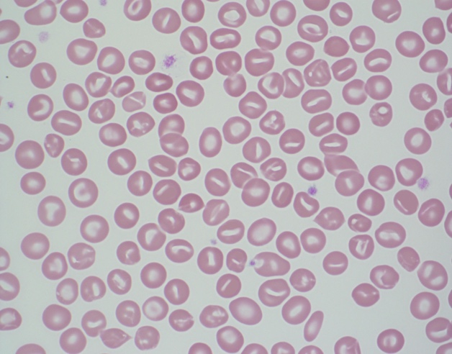

The patient is a 2 month old infant with pallor, jaundice, and splenomegaly. A CBC is notable for hemoglobin of 7.2 g/dL, MCV of 110 fL, MCHC of 24%, and reticulocyte count of 210 k/uL.
What is the most likely diagnosis?

- Hereditary elliptocytosis
- Neuroacanthosis
- Pyropoikilocytosis
- Southeast Asian Ovalocytosis
- Hereditary Stomatocytosis*

Review of the peripheral smear shows many stomatocytes. A stomatocyte is a uniconcaved red cell which results in central pallor that looks like a slit or a slightly curved rod.

Hereditary stomatocytosis is due mutations in Rh associated glycoprotein (RhAG) which leads to cation permeable red cells with resultant overhydration of the cell. These cells have greatly increased intracellular Na+.

The diagnostic laboratory features include peripheral smear stomatocytes (5-50%), hemolysis, macrocytosis, low MCHC, and positive osmotic fragility test.

25.
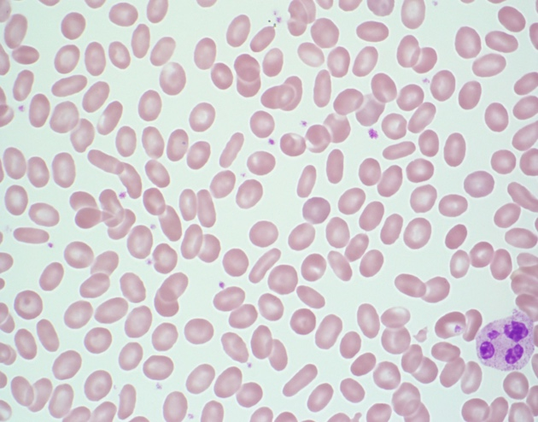

A five year old boy gets a CBC in preparation for a tonsillectomy. The laboratory calls with the finding shown on the smear. Most forms of this condition are inherited in what fashion:

- X-linked recessive
- Autosomal dominant*
- Autosomal recessive
- X-linked dominant
- Mitochondrial

The findings on the peripheral smear include many elliptocytes (ovalocytes). These are rod shaped cells with two parallel sides of equal lengths and two rounded ends. Central pallor is usually preserved.

Normal blood smears can contain a few ovalocytes/elliptocytes (<5%). When seen in large numbers, it is consistent with hereditary elliptocytosis (HE).

Typical heterozygous HE patients are usually asymptomatic. An osmotic fragility test is usually normal. Mutations in α–spectrin, β-spectrin, or protein 4.1 are responsible.

26.
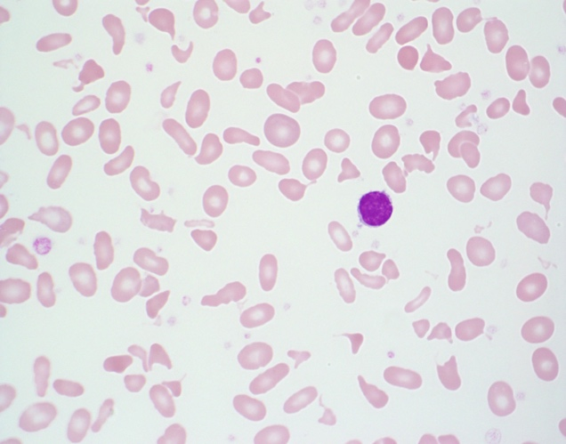

An infant presents with severe anemia, splenomegaly, and hyperbilirubinemia.
After reviewing the peripheral smear, the most likely diagnosis is:

- Thalassemia intermedia
- Hereditary spherocytosis
- Sideroblastic anemia
- Hereditary acanthocytosis
- Hereditary pyropoikilocytosis*

The smear shows anemia with marked poikilocytosis including schistocytes and elliptocytes. It is consistent with hereditary pyropoikilocytosis (HPP).

Essentially HPP is a more severe form of hereditary elliptocytosis when both parents have hereditary elliptocytosis and each passes on abnormal allele to offspring.

